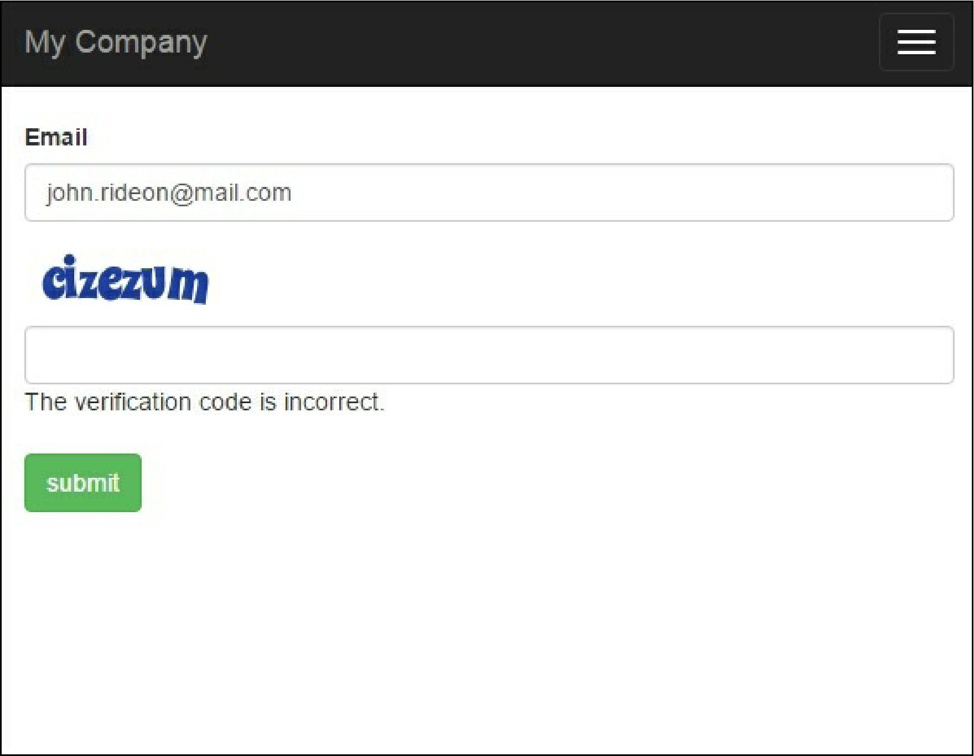

If there are no errors on the screen and no Captcha field on the form, most probably, you don’t have the GD PHP or Imagick extensions installed and configured. Imagick or GD is required for Captcha because it generates images. We have added several Captcha: :checkRequirements() checks, so the application will not use Captcha if the image cannot be displayed, but it will still work.

How it works...

In a view, we call the Captcha widget that renders the img tag with a src attribute pointing to the Captcha action we added to the controller. In this action, an image with a random word is generated. The word generated is a code that the user should enter into the form. It is stored in a user session and an image is displayed to the user. When the user enters the e-mail and verification code into the form, we assign these values to the form model and then validate it. For the verification of the code field, we use Captchavalidator. It gets the code from the user session and compares it to the code entered. If they don’t match, the model data is considered invalid.